Not All Breakouts Are Equal: How to Identify High-Quality Moves
Intro Image
Through today’s market analysis, we can deepen our understanding of market consensus and better distinguish what actually constitutes a high-quality breakout.

1️⃣ BTC
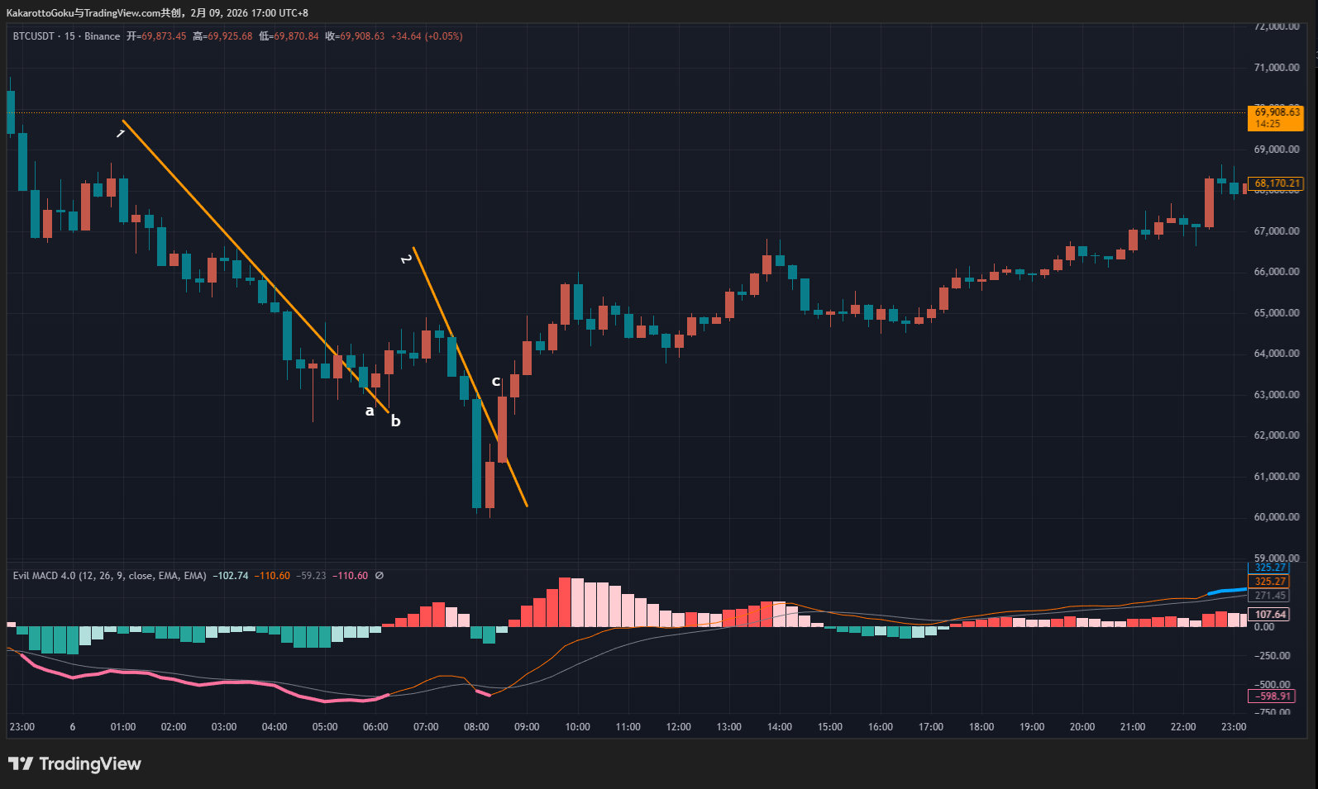
BTC Chart
At trendline 1 and trendline 2, BTC printed two pink warning signals, indicating potential bottoming areas. The key here is to compare the quality of the breakouts from these two trendlines.
Starting with trendline 1, upward breakout attempts appeared at both point A and point B. However, a closer look reveals that at point A, the combined length of the upper and lower wicks exceeds the candle body. Although this is not a doji, such long wicks clearly reflect intense competition between bulls and bears.
At point B, the candle has a long lower wick. In some theories, a long lower wick is interpreted as a sign of bullish strength. However, the existence of the lower wick itself means that bears were still actively pushing price lower and at least managed to reach that level. Therefore, whether at point A or B, neither breakout can be considered clean or decisive.
As a result, neither A nor B qualifies as a high-quality entry point. When clear two-sided conflict appears on the chart, the correct response is to remain patient, or to reduce position size and leverage. These types of entries are suitable only for probing or trial trades, and they lack strong follow-through value.
Now looking at trendline 2: Although this trendline was not previously tested by the market, the breakout at point C was clean and decisive, with almost no visible signs of struggle between bulls and bears. While C does have a very small upper wick, a direct comparison with points A and B shows that the bullish strength at C is overwhelmingly dominant. Therefore, point C represents the highest-quality entry among the three.
Additionally, from a Wyckoff perspective, we can observe that before points A and B, there was no terminal shakeout. The large bearish candle below trendline 2 can be interpreted as a Wyckoff “selling climax” or terminal shakeout, and many reversals originate from such events.

2️⃣ ETH
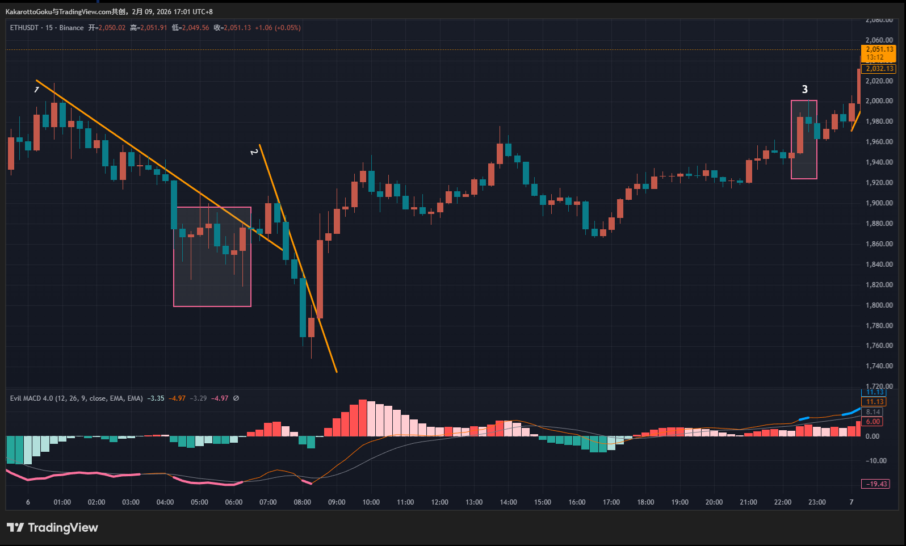
ETH Chart
ETH first formed a long pink warning zone, signaling a potential upside reversal at any time. A trendline then developed, and although it was broken upward by a small bullish candle near the end, this breakout deserves caution.
The breakout candle itself had no long wicks and appeared clean. However, within the pink boxed area ahead, we can see a large number of candles reflecting intense two-sided trading. Price action in this area did not strictly respect the trendline; instead, price detached from it at multiple points. This suggests that the trendline did not exert strong structural pressure, reducing the significance of the subsequent breakout.
This area therefore represents a risk zone. In such situations, it is better not to rush into a position, but to observe further, or—as with BTC—to reduce leverage and position size and treat it as a trial entry.
Later, trendline 2 formed. Compared with the first trendline, price action respected this one much more closely. There was no choppy back-and-forth like in the earlier pink box, and price did not deviate far from the trendline. As a result, trendline 2 carries greater structural validity.
When trendline 2 was broken by a strong bullish candle, this became the most attractive long opportunity. However, another issue must be considered: such sudden, powerful breakouts significantly expand the stop-loss distance. Therefore, even if choosing to follow this move, leverage and position size must be reduced, as market direction is never predictable and reversals can occur at any time. In trading, risk always comes first—this principle is never wrong.
Afterward, a short blue warning zone appeared, marking a potential top (highlighted by pink box 3). Notably, no valid trendline formed here. Instead, the structure consists of a sudden large bullish candle followed by a bearish doji. As such, this segment cannot be analyzed using trendline theory.

3️⃣ Gold
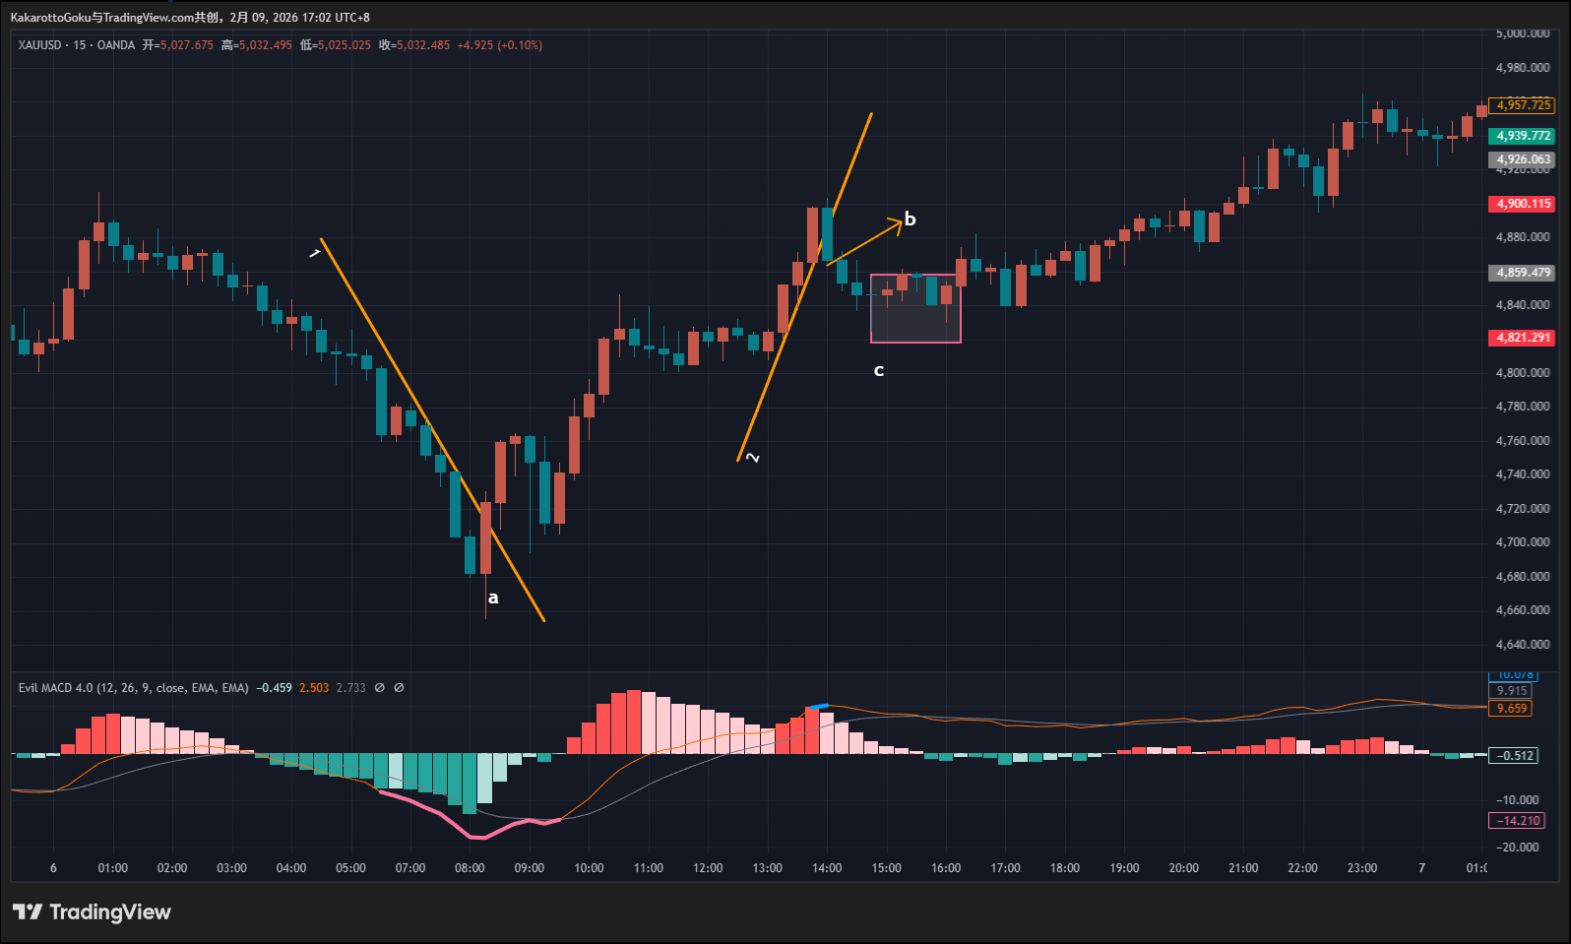
Gold Chart
We first observe a thick pink line indicating a bottom reversal warning. A trendline then formed and was tested by the market. At point A, price broke above the trendline. Although the candle at A has a lower wick, the candle body is larger than the wick, making the negative impact of the wick negligible.
This can be viewed as a structural transition from short to long. However, since the upward breakout was not particularly strong—the closing price was only slightly above the trendline—whether to follow this move depends on individual risk tolerance. More aggressive traders may choose to follow market consensus, while more conservative traders may opt to skip this opportunity.
Later, a short blue top warning appeared, followed by the formation of trendline 2. At point B, price broke downward. The candle at B is a nearly full-body bearish candle with minimal wicks and clearly breaks the trendline, making it a high-confidence structural shift from long to short.
After entering in the direction of market consensus at B, price later reached area C, where profits should be protected. If bearish consensus were truly strong, price would have moved quickly. Instead, area C shows two doji candles, followed by small-range candles, indicating that bearish consensus either failed to form or suddenly dissipated.
This candle behavior clearly reflects indecision or mutual disengagement between bulls and bears.

Summary
By comparing today’s market structures, we can see that randomness is always present. Even when we correctly identify a structural shift aligned with market consensus, it does not guarantee that price will continue moving smoothly in that direction.
Remember this key principle:
We can identify market consensus—but how far that consensus will carry price is impossible to predict.

